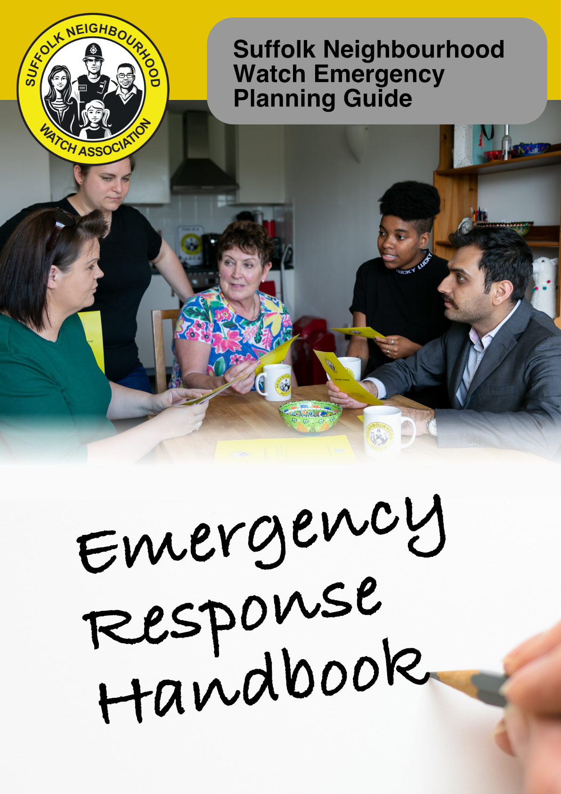

**<Enter name of Neighourhood Watch Group>**

**Emergency Procedures**

**INTRODUCTION**

Emergencies may affect only a few, but they can equally affect many – and it is important to have a plan in place to deal with such cases.

Core to Neighbourhood Watch values is the ability to help, support and look out for our neighbours, and the wider community. With that in mind the Suffolk Neighbourhood Watch Association has created this handbook.

The chances are that a NW scheme co-ordinator will be made aware of an emergency before an area co-ordinator knows, but this will depend on the structure of your community network.

This handbook offers simple measures to think about now, in the form of a basic guide – that may enable Neighbourhood Watch groups to reach out to their scheme members, and offer a level of help and support in times of emergency or crisis.

An area co-ordinator can escalate the level of support needed by including other schemes in the area to help in times of need.

We highly recommend discussing this plan with your local parish or town council, as in most cases they will already have an emergency plan in place.

That plan is likely to be part of a multi agency response process, usually co-ordinated through the Suffolk Resilience Forum which provides strategic, tactical and operational guidance on how to respond to a major incident.

Involvement with the local council enables Neighbourhood Watch schemes to become integral to the community response plan.

## *Create a response team by Area*

|  |
| --- |
| **FOR AREA COORDINATORS** |

In the event of an emergency, record here any primary co-ordinators or deputy co-ordinators of a Neighbourhood Watch scheme that have agreed to be available for contact to help deal with an emergency.

|  |  |  |
| --- | --- | --- |
| **Street / area of community covered** | **Name** | **Contact Information** |
|  |  | Home -  Work -  Mobile -  e-mail - |
|  |  | Home -  Work -  Mobile -  e-mail - |
|  |  | Home -  Work -  Mobile -  e-mail - |
|  |  | Home -  Work -  Mobile -  e-mail - |
|  |  | Home -  Work -  Mobile -  e-mail - |

## *Create a response team by Scheme*

|  |
| --- |
| **FOR SCHEME COORDINATORS** |

In the event of an emergency, primary co-ordinators of individual schemes can record here any members of their scheme that have agreed to be available for contact to help deal with an emergency.

|  |  |  |
| --- | --- | --- |
| **Street / area of community covered** | **Name** | **Contact Information** |
|  |  | Home -  Work -  Mobile -  e-mail - |
|  |  | Home -  Work -  Mobile -  e-mail - |
|  |  | Home -  Work -  Mobile -  e-mail - |
|  |  | Home -  Work -  Mobile -  e-mail - |
|  |  | Home -  Work -  Mobile -  e-mail - |

|  |
| --- |
| **CALL CASCADE** |

If you have a large number of volunteers it can be very time consuming to ring round everyone with the information. By organising a ‘call cascade’ system valuable time can be saved and it ensures all members of the team have been contacted.

The guide below shows an example. Please amend to suit your own requirements

Example:

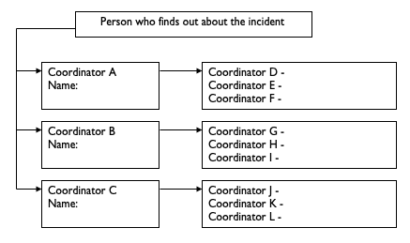

***Identify vulnerable people in a scheme***

|  |
| --- |
| **VULNERABLE MEMBERS WHO MAY NEED PARTICULAR HELP DURING AN EMERGENCY** |

There will be some people in your Neighbourhood Watch area that are likely to need extra support in an emergency. You might like to either:

* Gather their names and contact details, and include them in this plan so that all emergency volunteers have access to their details in an emergency, regardless of whether the local coordinator is available. This information will need to be kept up to date, and will need to be stored securely, or
* Let people who may need extra support have a copy of the emergency contact list on page 5.

|  |  |
| --- | --- |
| **Name, Address and Contact Information/vulnerability** | **Name, Address and Contact Information/ vulnerability** |
|  |  |
|  |  |
|  |  |
|  |  |
|  |  |

|  |
| --- |
| **COORDINATOR ACTIONS IN AN EMERGENCY** |

* Ensure that your own family is safe first, and that your house is secure
* Assess the impact of the emergency on your scheme
* Consider who you need to contact (See External Contact details on page 9.)

Next steps:

* Make contact with your scheme emergency volunteers
* Tune into the local radio station and listen for public advice messages
* If applicable, consider instructing emergency volunteers to:
  + Prioritise support to vulnerable people
  + Help people move valuable and sentimental items upstairs
  + Help deploy any flood protection products they might have
  + Provide some immediate shelter if people have had to leave their homes
  + Help look after pets/livestock
  + Provide transport to family and friends

Where events involve emergency services and the need to evacuate homes, households should be reminded to:

* + Turn off electricity, gas and water supplies and unplug appliances
  + Take mobile phones and chargers.
  + Take some spare clothes if possible.
  + Take prescribed medication with them.
  + Take cash and credit cards.
  + Lock all doors and windows.

|  |
| --- |
| External Contact Details FOR SUFFOLK AREA |

Use this section to add relevant points of contact for both local and area contacts:

* Emergency Fire, Police, Ambulance and Coastguard - 999.
* Police Non Emergency Number - 101.
* NHS Direct - 111.
* Suffolk County Council (emergency duty service) – **0808 800 4005**
* Suffolk County Council website: https://www.suffolk.gov.uk
* Parish/Town Council website: - xxxxxxxx.
* Parish/Town Council email: xxxxxxxx(may only monitored in an emergency).
* Environment Agency Floodline - 0845 988 1188
* Environment Agency Incident Hotline – 0800 80 70 60
* Gas Emergency Service and Gas Escapes - 0800 111 999.
* Electricity Emergency Service and Supply Failures - 105.
* Anglian Water Emergency - 0800 771881
* Radio Suffolk –Broadcasts on 95.5, 95.9, 103.9 and 104.6 FM.
* [www.bbc.co.uk/suffolk](http://www.bbc.co.uk/suffolk)
* [www.metoffice.gov.uk](http://www.metoffice.gov.uk)

|  |
| --- |
| **ADDITIONAL CONTACT DETAILS** |

Use this section to record additional contact information that you already use on a regular basis or for people with specialist skills or resources – for example – tenants associations, village hall committee, Town or Parish Councils.

|  |  |  |
| --- | --- | --- |
| **Name** | **Role** | **Contact Information** |
|  |  | Home -  Work -  Mobile -  e-mail - |
|  |  | Home -  Work -  Mobile -  e-mail - |
|  |  | Home -  Work -  Mobile -  e-mail - |
|  |  | Home -  Work -  Mobile -  e-mail - |
|  |  | Home -  Work -  Mobile -  e-mail - |
|  |  | Home -  Work -  Mobile -  e-mail - |
|  |  | Home -  Work -  Mobile -  e-mail - |
| People/Businesses that have offered to help in an **emergency** | | |

Use this section to record additional contact information that you already use on a regular basis or for people with specialist skills or resources – for example – tenants associations, village hall committee, Town or Parish Councils

|  |  |
| --- | --- |
| **Resource** | **Contact Information** |
| Name:  <Eg Supplies from Village Shop | Home -  Work -  Mobile -  e-mail - |
| Name:  <Eg Staff from workshop available to help in an emergency | Home -  Work -  Mobile -  e-mail - |
| Name:  <Eg Access to Tractor / Plough | Home -  Work -  Mobile -  e-mail - |
| Name:  <Eg Four Wheel Drive | Home -  Work -  Mobile -  e-mail - |
| Name:  <Eg Catering/Listening/Supporting | Home -  Work -  Mobile -  e-mail - |
| Name:  <Eg Catering/Listening/Supporting | Home -  Work -  Mobile -  e-mail - |

|  |
| --- |
| **CALLING CARD** |

You can use this calling card to inform your scheme members of your contact details in the event of an emergency. This can be used in a similar way by all volunteers.

